OS Assignment-01

By-Jeetu Mehra
U24AI032

Question 1 : Practice basic linux commands- ls, cd, pwd, mkdir, rm, rmdir, touch, cp, mv, cat, chmod, kill, top, ssh, etc.
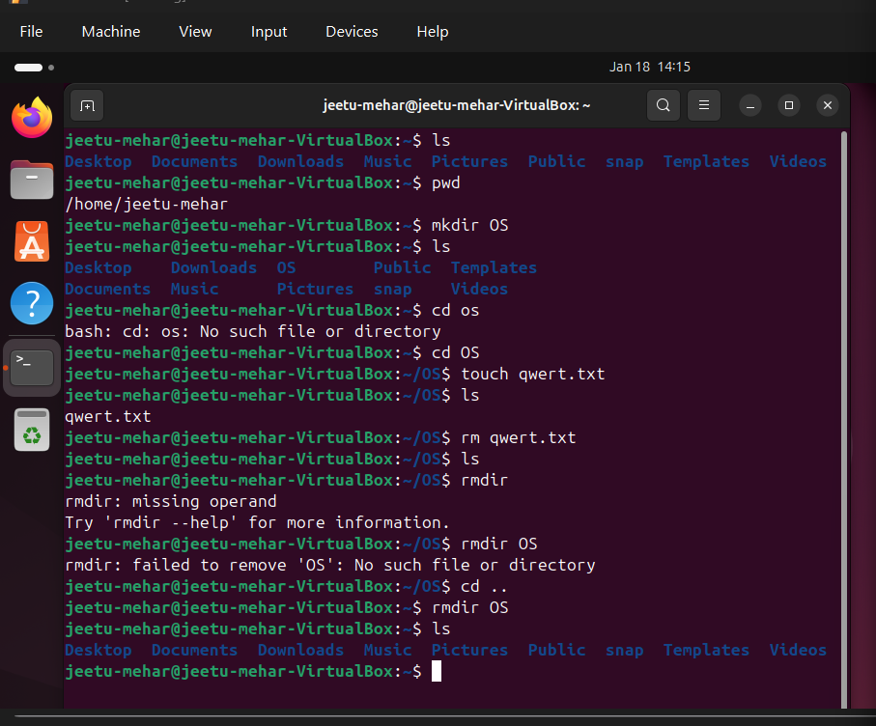
Output:

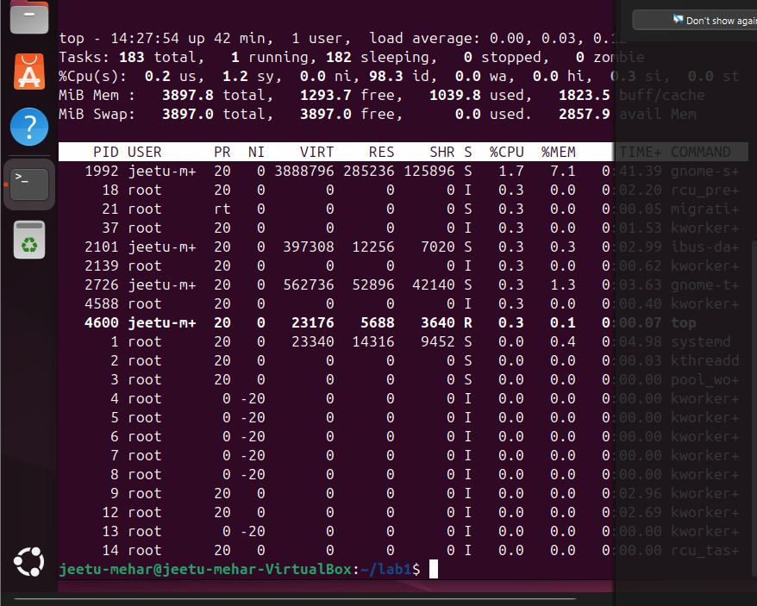
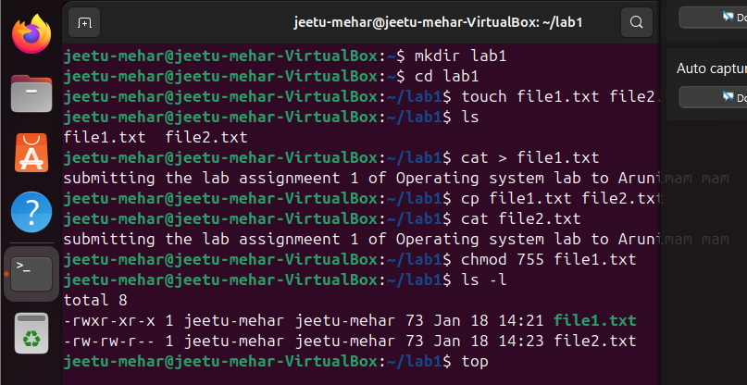

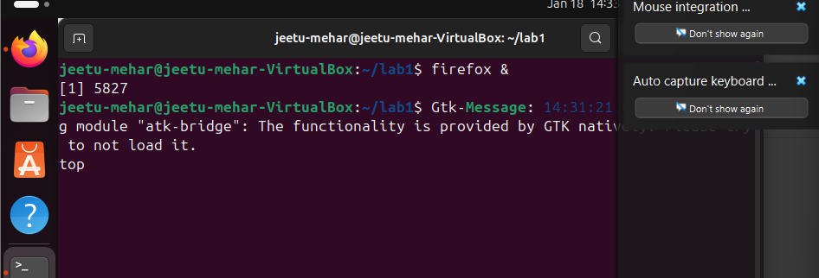
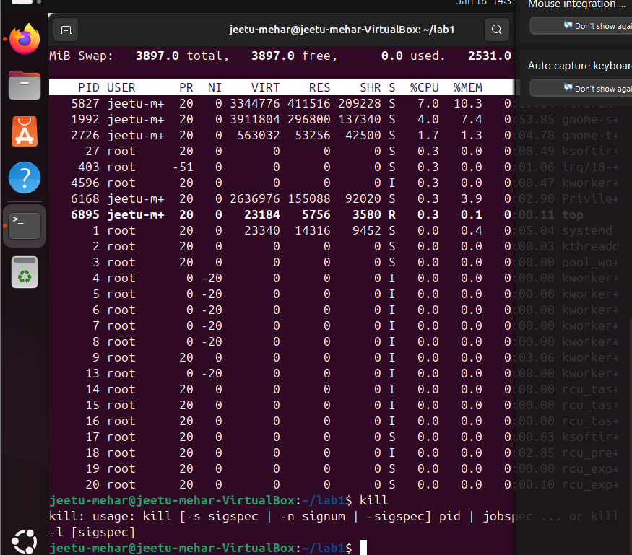

2) Create a folder using mkdir with the name “SVNIT”. Create subfolders inside the SVNIT folder as AI, CSE, MED,ECE
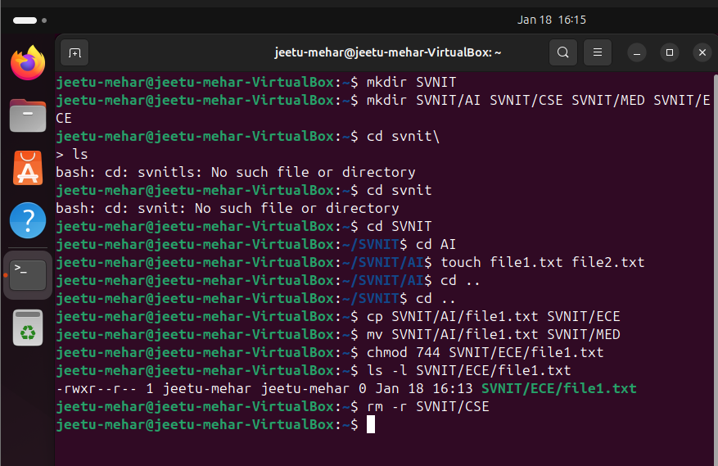

Q.3) Practice Linux commands related to process management
1. Start a browser and check the process ID of the browser using Top
command
2. Kill the browser process using “kill” command
3. Change the priority of any user process by using “nice” command

